**Using a Phoenix Contact SD card to deploy a project onto multiple controllers**

This script has been developed to copy AXC F 2152’s filesystem from an external SD card to the internal SD card on a clean* AXC F 2152.

*A clean AXC F 2152 means there is no code on the controller. All code can be cleared from the controller with a Type 1 Reset.

**Pre-requisites:**

**To deploy this project, you MUST have a Phoenix Contact SD card (Part# 1043501 or 1061701), and your project must not exceed 400MB.**

**SD card configuration**

1. Go to the web based management (can be accessed by typing the IP address of the controller in a browser), and under Security and SD card ensure the Support external SD Card is selected. If it is not selected, select it and hit apply and reboot the controller.

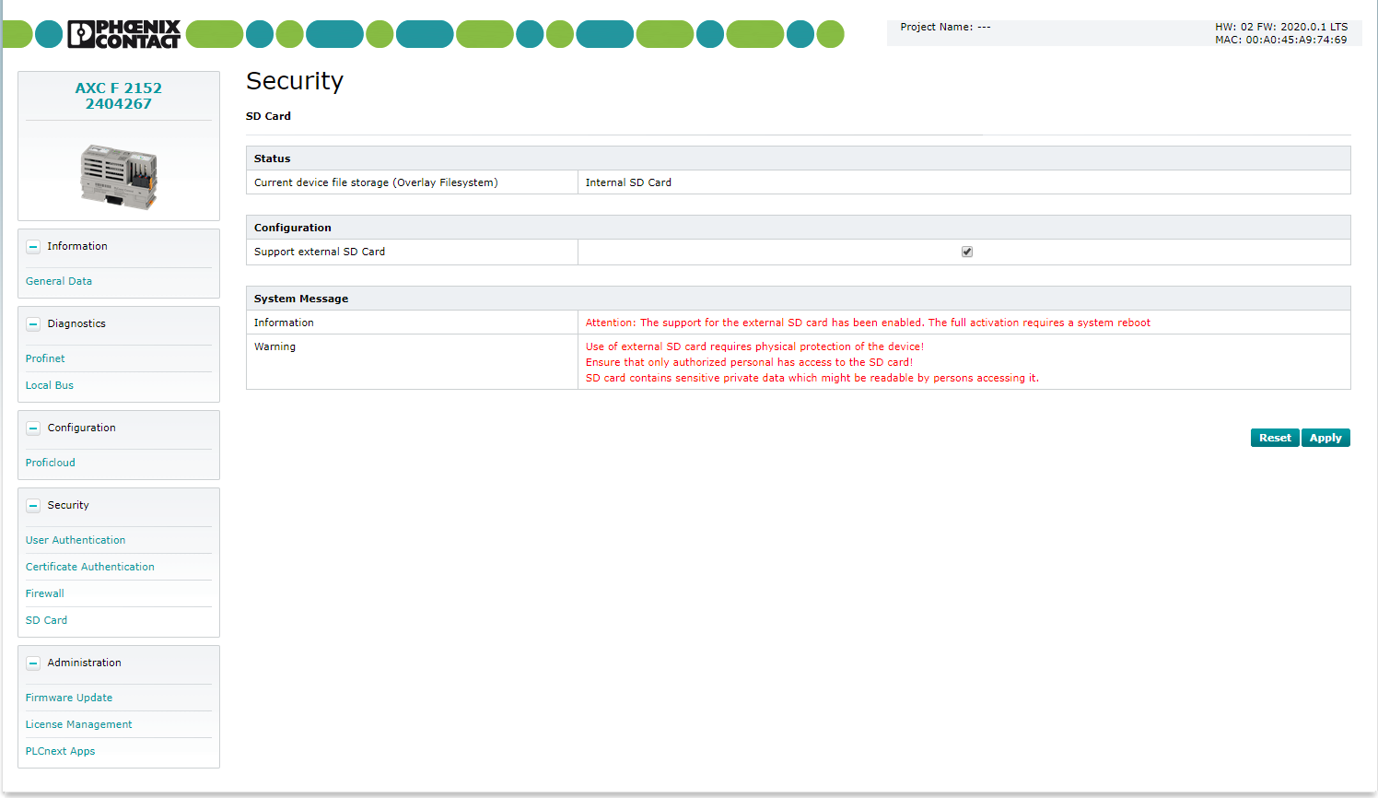

2

3

1

1. Once selected and rebooted (or if it was already selected), remove power from the AXC F 2152 (or remove it again if it was not selected). Once the AXC F 2152 is powered off, insert the SD card and turn on the AXC F 2152.
2. Once online, deploy your entire project onto the controller (PLCnext Engineer and programs running in Linux if applicable).
3. Once the entire project is deployed and functional with the external SD, download the zip file from <http://www.github.com/plcnextusa/SDcardDeploy> and extract it.

(see Appendix 1 for more information)

1. Open up WinSCP and connect to the controller.
2. Once connected, copy the PLC_move folder, the install.sh to the /opt/plcnext/ directory.
3. **Also copy over the .raucb file for the firmware of your project.** This is needed to make sure the firmware of the new AXC F 2152 matches the project being deployed on the device.

(see Appendix 2 for more information)

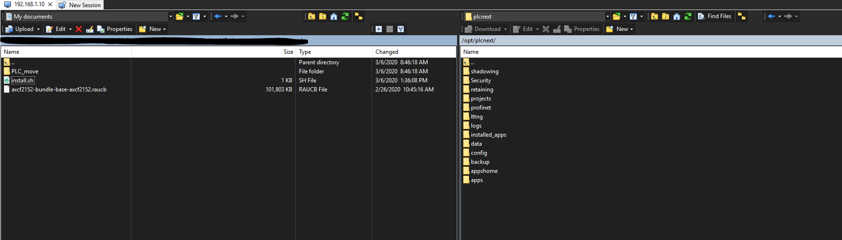

**NOTE: If the .raucb file is not also copied onto the controller this will cause the transfer to fail if firmware does not match!**

1. Once all of the necessary files are on the controller, open a session in PuTTY and connect to the controller.
2. Log into the root user, ensure you are in the /opt/plcnext/ directory.

(see Appendix 3 for more information)

1. Run the below commands:

chmod 777 install.sh

./install.sh

1. Now the AXC F 2152 will begin the copying process. The AXC F 2152 will reboot, and once the RUN LED is solid green the process is complete.

DO NOT disconnect from the AXC F 2152 until the controller reboots, and DO NOT remove the SD card until the AXC F 2152 is running after the reboot.

1. Once this process is complete, power down the AXC F 2152 and remove the SD card.

**Project deployment on a AXC F 2152:**

1. Now when you want to deploy your project on a brand new AXC F 2152, insert the SD card and power on the device. If the AXC F 2152 has been used previously, see Appendix 4.

The copying process can take up to 5 minutes and the AXC F 2152 will reboot once if FW is the same, and twice if the FW is different.

**NOTE: The AXC F 2152 must not have an existing project on it and the external SD support checkbox must be checked! (checked by default, see step 1 of SD Configuration for more details)**

1. The new AXC F 2152 will reboot on its own, and the project will automatically be deployed.
2. Once the AXC F 2152 is running after a reboot, power off the controller and remove the SD card.
3. Once the SD card is removed, the AXC F 2152 can be powered back on and the project will be fully deployed.

**Removing the automatic deploy from the SD card:**

If you no longer need the deployment or have a new project revision, you will need to clear the SD card.

**Read the entire process before executing**

1. To do so, ensure that the external SD card is supported. See step 1 of SD Configuration for more details
2. Once the checkbox is checked and settings are applied, reboot the controller.
3. Check the web based management to ensure that an external SD card is supported.
4. Once that has been verified, power off the AXC F 2152.
5. Insert the SD card, hold down the reset button, and turn on the AXC F 2152.
6. Once the RUN and FAIL LED’s are solid, release the reset button. All LEDs will show yellow.
7. Once the AXC F 2152 comes back online, the SD card is now cleared, and can be used for a new deployment.

**Appendix 1: To download a repository from Github**

1. Navigate to the page linked above.

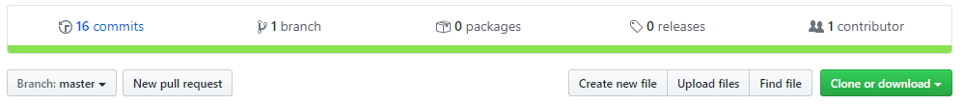

1. Click the Clone or download button shown above, and select Download ZIP.
2. Extract the files on your PC.

**Appendix 2: To see your current FW version**

1. Open a browser and navigate to the IP address of the AXC F 2152.
2. Select Easy Configuration, and log in as admin with the password printed on the housing.
3. As seen in the picture below, the FW is listed in the top right corner.

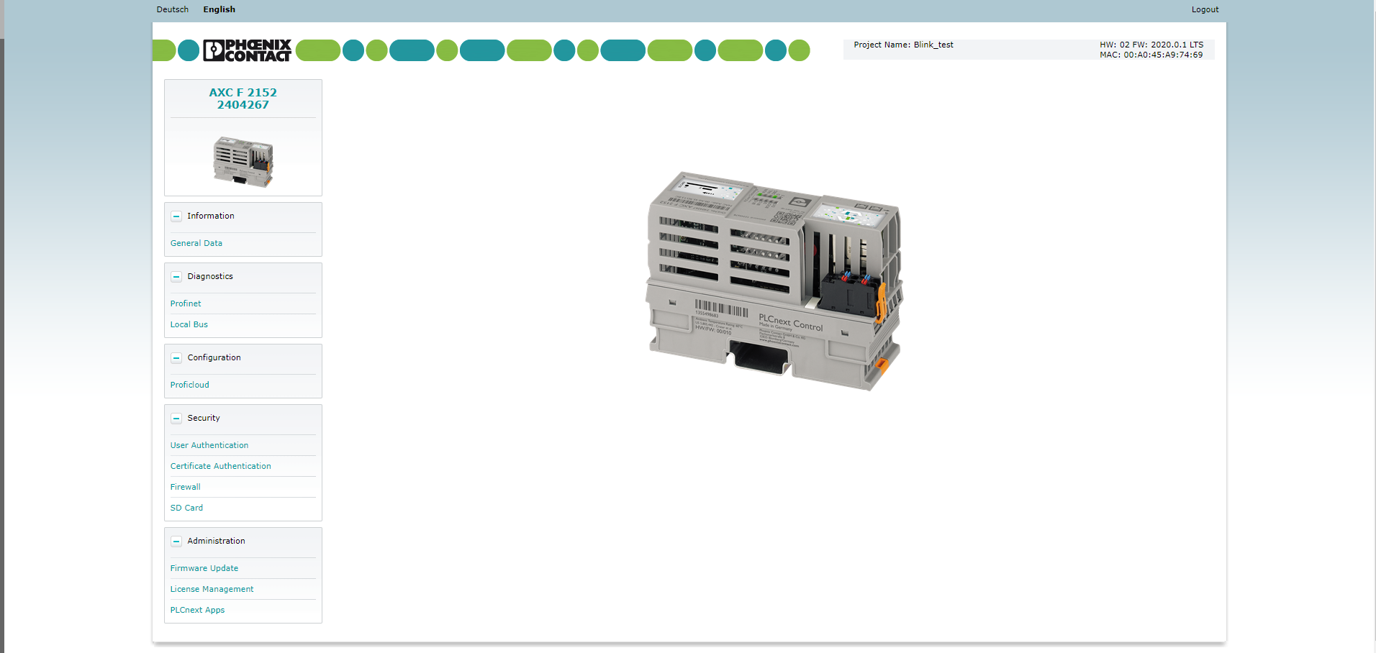

Downloading the firmware file onto your computer

1. Navigate to the AXC F 2152 product page on [www.phoenixcontact.com](http://www.phoenixcontact.com)
2. Under the downloads tab, select the Firmware link.
3. Scroll down until you find the correct FW version of your controller.
4. Download the ZIP file, extract the ZIP file, and run the MSI installer.
5. The default path of the FW file is C:\Users\Public\Documents\PLCnext\Firmware
6. The file you are needing to copy is the “.raucb” file as shown in the picture below

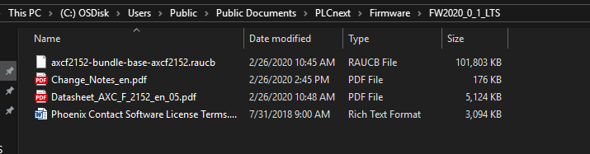**Appendix 3: To create a root user**

1. Open puTTY and connect to the AXC F 2152.
2. Type the command “sudo passwd root”
3. Enter the password printed on the housing
4. Follow the instructions written in the command line
5. To login as a root user, type the command “su” [enter] then followed by the password you just created.

